Lab - Create a Virtual Install of Server 2012r2 Core Using VirtualBox

For this lab, students first need to create a second full install with GUI of Server 2012 r2 standard edition. This lab demonstrates how to covert a full install with GUI to either minimal install with Server Manager or an install of Server 2012 r2 Core.

Overview

In this lab, students will switch between full GUI and Server core in windows 2012 using Powershell. Most of what you learn in this lab will be testable on the 70-410 exam.

The Server Core installation installs the operating system in non-GUI with minimal footprint and helps to secure the server running Hyper-V role. The benefits of using core server are:

* Reduced attack surface
* Reduced maintenance
* Consume fewer hardware resources
* Increased stability due to fewer running applications

The Full Server Installation installs the operating system with full GUI allowing us to perform all administration and Hyper-V related operations locally on the server.

Begin the Lab!

Installing Server 2012 r2 with GUI

We begin the process of creating a virtual machine of Server 2012 r2.

In our previous lab, we downloaded an ISO image of Server 2012 r2 Standard Edition and saved it to a location on our machine.

Download the ISO

Use this [direct link](https://www.dropbox.com/s/bzvi2ujt7uhufpd/9600.17050.WINBLUE_REFRESH.140317-1640_X64FRE_SERVER_EVAL_EN-US-IR3_SSS_X64FREE_EN-US_DV9.ISO?dl=0) to download the ISO file from the instructors DropBox account.

Download direct from Microsoft: [Server 2012 r2 ISO image](https://www.microsoft.com/en-us/evalcenter/evaluate-windows-server-2012-r2)

Once you have completed the downloaded the ISO image for Server 2012 r2 standard, open VirtualBox and begin creating a virtual install of Server 2012 r2.

To begin the 2012 r2 creation process, open VirtualBox and from the upper left corner, click on the New button.

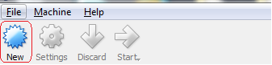

This launched the Create Virtual Machine Wizard.

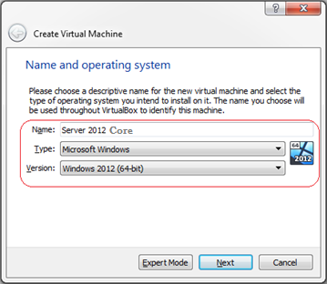

On the next window, accept the default of 2014 MB of RAM. Click next.

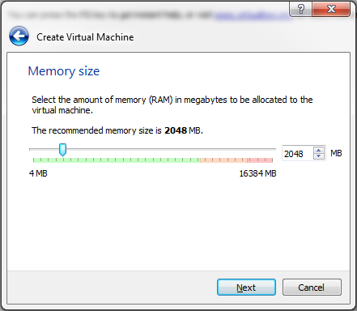

On the next screen, accept the default to create a virtual hard disk now. Click create.

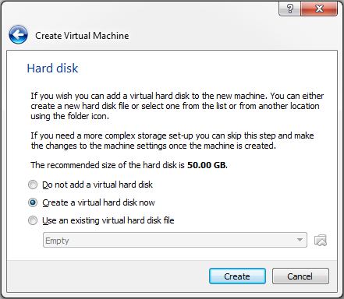

Accept the default for the hard disk type as VDI. Click next.

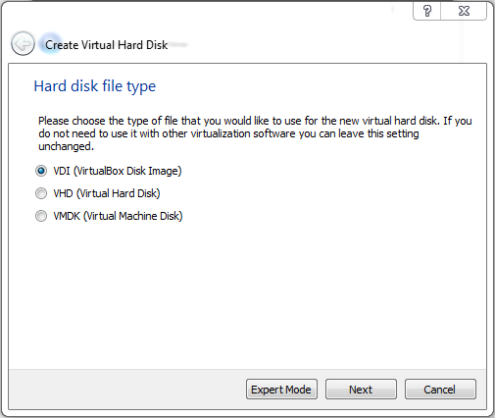

On the next screen, accept the default for the storage on the physical hard disk to be dynamically allocated.

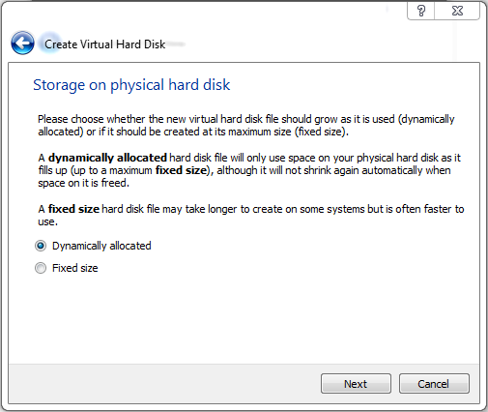

On the next screen, accept the default for the file location and size of 50 GB. Click create.

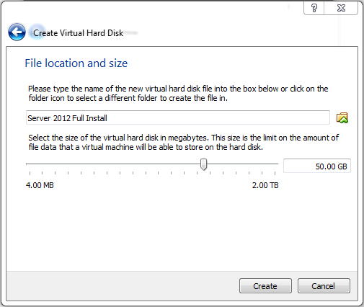

From the left window pane, ensure your disk for Server 2012 Full Install is highlighted and from the grey taskbar, click on the start arrow.

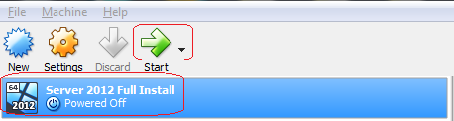

From the select Start-up Disk screen, click on the folder browse button and browse to the download location for your ISO image of Server 2012 r2. Double-click the ISO image and click the green Start arrow.

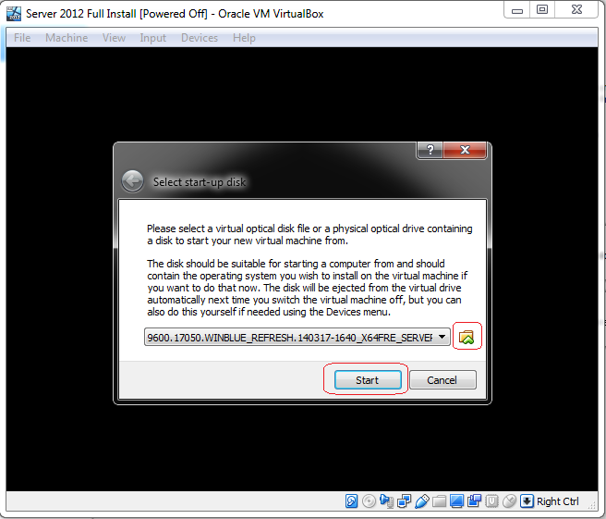

Step 9: VirtualBox begins the install.

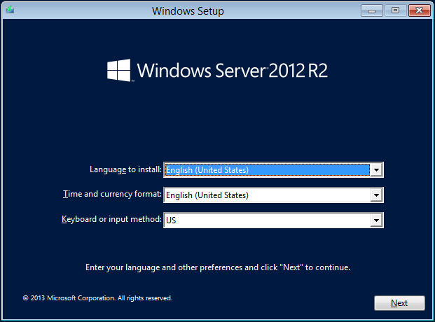

15. Click on Next to start the Windows Server 2012 R2 installation.

Click on Install now

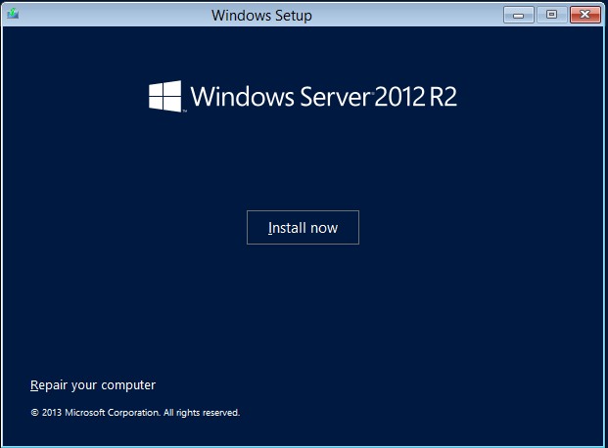

16. Select the operating system that you wish to install. Regardless if you install the Server 2012 R2 Datacenter or the 2012 R2 Standard version, you want the installing package that includes the GUI. Otherwise, you end up with just the Server 2012 Core and no GUI.

Server 2012 Datacenter can handle more RAM and CPU options, but they are identical operating systems. Students may use either for their labs.

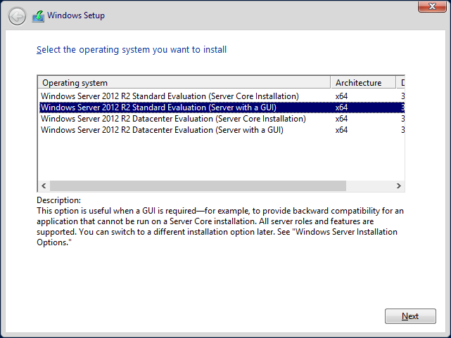

17. Accept the license agreement.

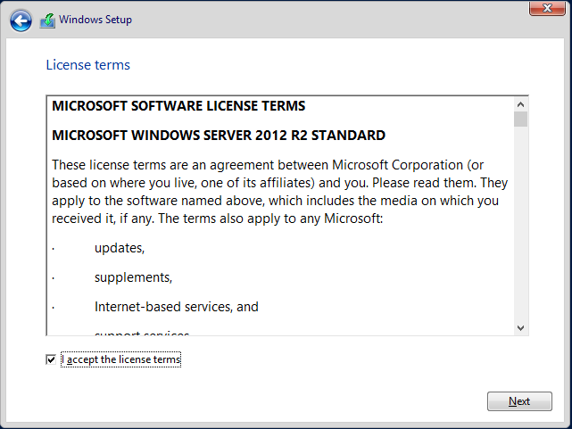

18. Select Custom Install Windows only (advanced).

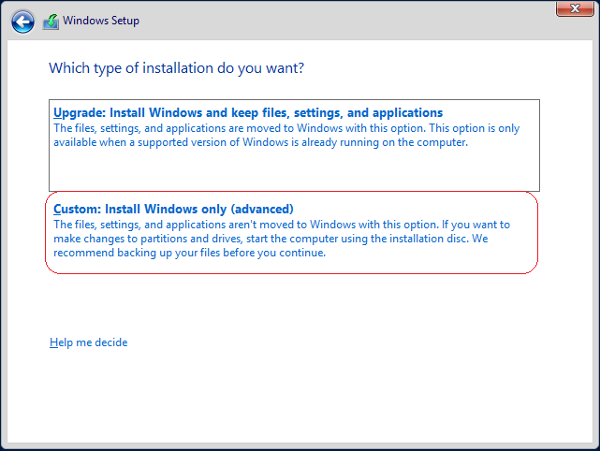

19. Nothing to do here but click Next.

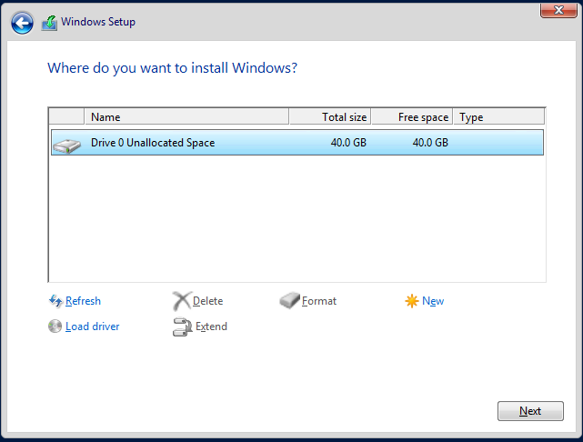

Server 2012 R2 beings the file copy process. Take a break while the installation finishes.

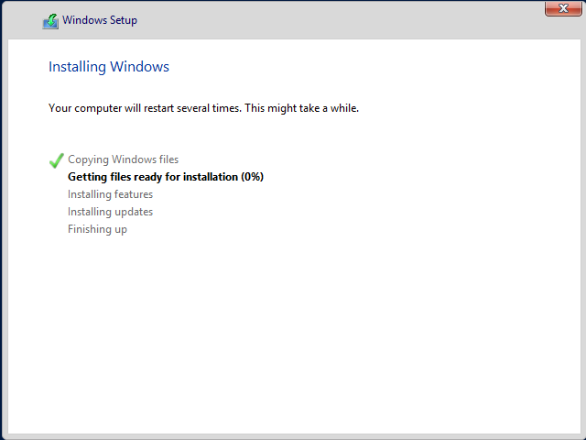

Windows will reboot. Be patient!

Before Server 2012 will allow you to log in, you must configure the password for the administrator account. Do try and remember your password. If you forget it, you will need to remove the machine and files from the VirtualBox Player Management Console and begin anew.

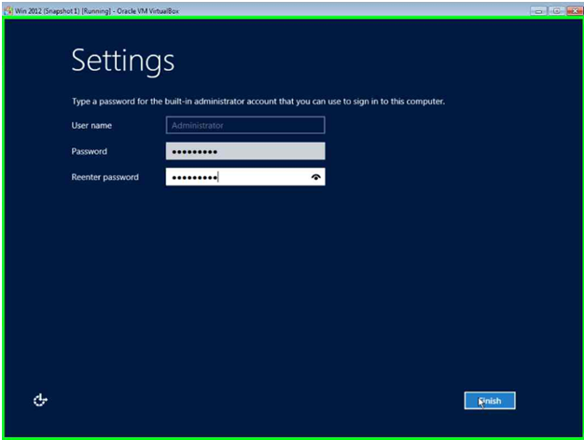

21. Click Finish. Welcome to Windows Server 2012 R2!

We begin the lab by converting our full installation with GUI to Server Core with GUI Management and then to Server Core.

The best way to complete this lab is to copy and paste the commands into Powershell.

Change from Full Server to Minimal Interface Mode

From your Server 2012 r2 desktop, launch Powershell. Type the following commands in one line at a time.

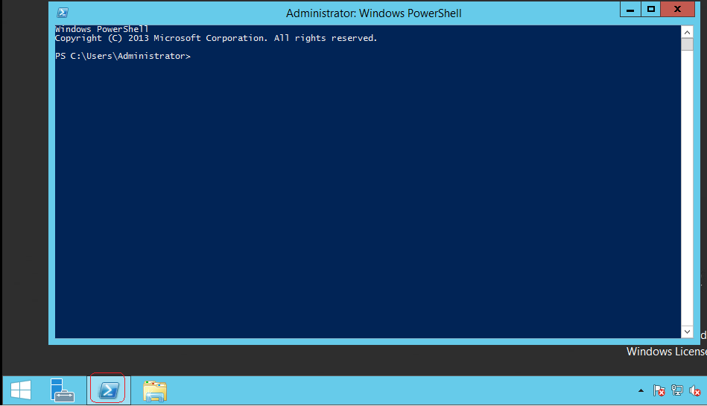

Import-Module ServerManager

[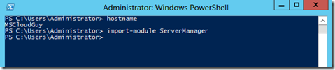](http://blogs.technet.com/cfs-file.ashx/__key/communityserver-blogs-components-weblogfiles/00-00-00-84-40-metablogapi/7701.image_5F00_1CD44DD2.png)

Uninstall-WindowsFeature Server-Gui-Shell -Restart

[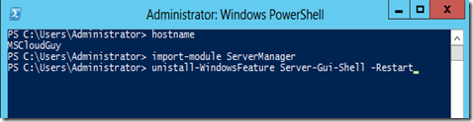](http://blogs.technet.com/cfs-file.ashx/__key/communityserver-blogs-components-weblogfiles/00-00-00-84-40-metablogapi/7457.image_5F00_0BA0702F.png)

[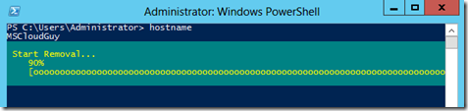](http://blogs.technet.com/cfs-file.ashx/__key/communityserver-blogs-components-weblogfiles/00-00-00-84-40-metablogapi/7838.image_5F00_1CC42805.png)

Reboot the Server

[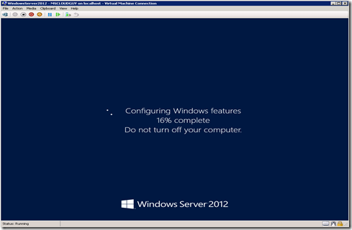](http://blogs.technet.com/cfs-file.ashx/__key/communityserver-blogs-components-weblogfiles/00-00-00-84-40-metablogapi/0167.image_5F00_2081CCD5.png)

Server Core with GUI Management (Minimal Server Interface)

Launch the PowerShell Window

[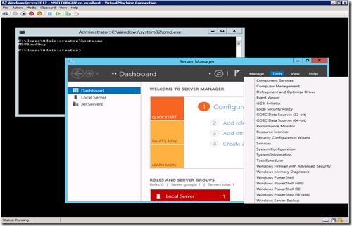](http://blogs.technet.com/cfs-file.ashx/__key/communityserver-blogs-components-weblogfiles/00-00-00-84-40-metablogapi/3683.image_5F00_06EA19DB.png)

Type Powershell at the command prompt and hit Enter.

[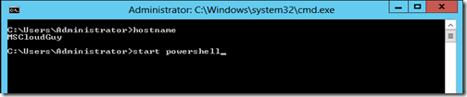](http://blogs.technet.com/cfs-file.ashx/__key/communityserver-blogs-components-weblogfiles/00-00-00-84-40-metablogapi/6813.image_5F00_4E2F4A00.png)

[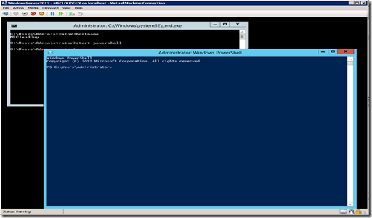](http://blogs.technet.com/cfs-file.ashx/__key/communityserver-blogs-components-weblogfiles/00-00-00-84-40-metablogapi/0601.image_5F00_4B39E54D.png)

Uninstall-Windowsfeature Server-Gui-Mgmt-Infra -Restart

[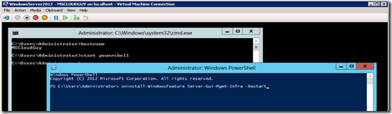](http://blogs.technet.com/cfs-file.ashx/__key/communityserver-blogs-components-weblogfiles/00-00-00-84-40-metablogapi/4807.image_5F00_53F9C7CC.png)

Press Enter and uninstall begin.

[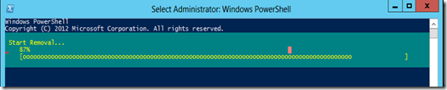](http://blogs.technet.com/cfs-file.ashx/__key/communityserver-blogs-components-weblogfiles/00-00-00-84-40-metablogapi/7674.image_5F00_31FE3F7B.png)

Reboot the Server.

[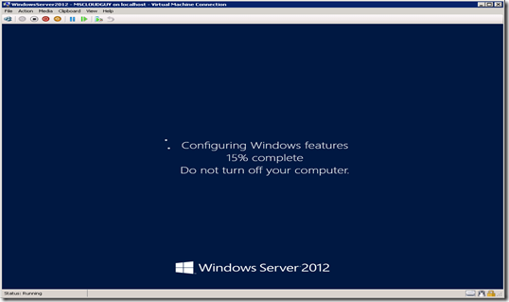](http://blogs.technet.com/cfs-file.ashx/__key/communityserver-blogs-components-weblogfiles/00-00-00-84-40-metablogapi/5428.image_5F00_3C6EEDCE.png)

To get back our full GUI install, we can use the command prompt using the DISM (*Deployment Image Service Manager*) utility.

Dism /online /enable-feature /featurename:ServerCore-FullServer /featurename:Server-Gui-Shell /featurename:Server-Gui-Mgmt

While the DISM tool works fine, it is the PowerShell that allows you to manage more than one server remotely. The script in PowerShell would be nearly as simple:

Import-Module Dism   
Enable-WindowsOptionalFeature –online -Featurename ServerCore-FullServer,Server-Gui-Shell,Server-Gui-Mgmt

[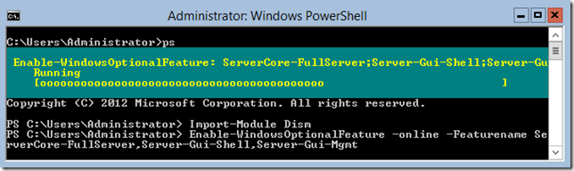](http://blogs.technet.com/cfs-file.ashx/__key/communityserver-blogs-components-weblogfiles/00-00-00-48-12-metablogapi/1385.image_5F00_026610C4.png)

To remove the GUI features or Convert Server full GUI back to Server Core using DISM, use the following command.

Dism /online /Disable-feature /featurename:ServerCore-FullServer /featurename:Server-Gui-Shell /featurename:Server-Gui-Mgmt

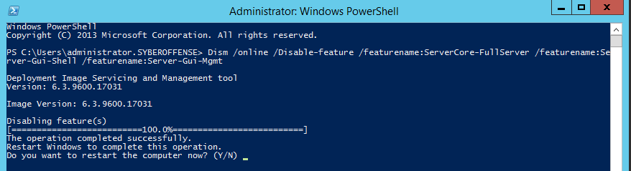

In this lab, we looked at the different ways we can change from Server core to Full GUI and the Server core with the minimal graphical user interface. But there is still another way to get the MiniShell with Server Core.

MinShell (Minimum Shell) offers the administrator the best of both worlds.  You have the GUI management tools (Server Manager) but no actual GUI, which means that you are still saving the resources and providing a smaller attack surface but with full manageability.

[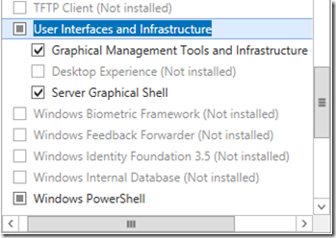](http://blogs.technet.com/cfs-file.ashx/__key/communityserver-blogs-components-weblogfiles/00-00-00-48-12-metablogapi/5504.image_5F00_1612FA58.png)

Under **User Interfaces and Infrastructure** there are three options that allow the server administrator to customize the visual experience according to his needs.

The **Graphical Management Tools and Infrastructure** is the Server Manager, along with the other GUI tools that we use every day to manage our servers.  It also includes the **Windows PowerShell Integrated Scripting Environment (ISE)** which allows administrators an easier to create and manage their PowerShell scripts.

The **Desktop Experience** gives the administrator the full desktop experience – similar to the **Windows 8** client OS – including features such as Picture and Video viewers.

The **Server Graphical Shell** is exactly that: the GUI.  In other words, we can turn the GUI on or off by using the **Add Roles and Features Wizard** (and the **Remove Roles and Features Wizard**).

**Summary:**

With the MinShell, the Add Roles and Features Wizard is still available, but not in Server Core

If you install the full GUI and then remove the components, re-adding them isn’t a problem; however, if you install Server Core from the outset then attempt to add the GUI (and Management), you will need to have the installation media available as bits are not copied to the installation folder when Core is created.

The other caveat is using the wrong command when uninstalling the GUI converting to Core. Replacing the **uninstall** command with **remove**, deletes the packages for the GUI and management tools from the install folder.

End of the lab!